**Lab Tasks**

**Task# 1.**

Write a C program to display “your name 3 times in separate lines” in C.

**Task# 2.**

Develop following program and discuss the behavior of the code.

#include <stdio.h>

int main() {

printf("Hello ,%cworld!", 0x0A);

return 0;

}

**Task# 3**.

Develop following program and discuss the behavior of the code.

#include <stdio.h>

int main(void) {

printf("Geeks Hub\b\b\b\bF");

return (0);

}

**Task# 4**.

Create a C program to print formatted output as below. (Hint: use printf() ﬁeldwidth speciﬁer)

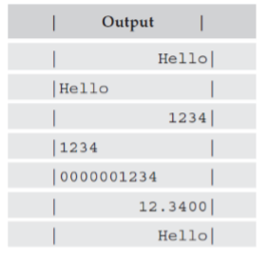

**Task# 5.**

Write a C program to declare two integers and one ﬂoat variables then initialize them to 10, 15, and 12.6. Also print the variable values on the screen.

**Task# 6.**

Write a C program to prompt the user to input 3 integer values and print those values in forward and reversed order. **(Research Task)**

**Task# 7.**

Write a C program to swap two variables with and without using third variables.

**Task# 8.**

Write down an algorithm to find out whether a number belongs to the Fibonacci series or not.

**Task# 9.**

Write down an algorithm to find out whether a number is even or odd.

**Task# 10.**

Write down an algorithm to find the solution to any problem you can find from the Internet from any domain you are interested in.